**MS SQL SERVER**

**Standard Operating Procedures**

**(SOP)**

**How to schedule a report in SSRS**

Submitted to



**By**



CIS, Wipro Limited

Document Details

|  |  |
| --- | --- |
| Project Name | Innogy SE |
| Account | CIS |
| IT Component/Application Title | How to schedule a report in SSRS |
| Current Version | 1.2 |
| List of Contributors | Pradipkumar Kansara, Kiran Bhalekar, Ayushi Gautam, Sivakumar Goud, Pramod Patil |
| Customer Contact Information |  |

Version History

(All revisions made to this document must be listed in chronological order. All revisions must be approved. Review and Approval can be done by an internal source or by the customer)

|  |  |  |  |  |  |
| --- | --- | --- | --- | --- | --- |
| Version | Date of Revision | Description | Author | Reviewed By | Approved By |
| 1.0 | 28-11-2017 | Initial Draft | Kiran Bhalekar | Pradipkumar Kansara | Santosh Badiger |
| 1.1 | **04-12-2017** | **Document Completed** | **Kiran Bhalekar** | **Pradipkumar Kansara** | **Santosh Badiger** |
| 1.2 | **30-10-2018** | **Updated the content** | **Pramod Patil** | **Pradipkumar Kansara** | **Santosh Badiger** |

Document Distribution List

|  |  |  |
| --- | --- | --- |
| **Sr.No** | **Name and Company** | **Purpose** |
| **1** | RWEIT-SQLDBA | **This document is about how to schedule a report in report server** |

**TABLE OF CONTENT**

1. Purpose 4

2. Scope 4

3. Steps To schedule a report 4

4. Reference 17

# 

# Purpose

This document is to cover how to schedule a report to an instance of SSRS and integration of reports to Application.

# Scope

This document is prepared for GSMC Wipro sustenance team and provides the concepts of scheduling report in report server

# Steps to schedule a report

**Step 1:**

RDP to the server using service account

**Step 2:**

The report will execute based on schedule time and place the output of file in shared path.

1. Go to Search tab once you login to the server as below:

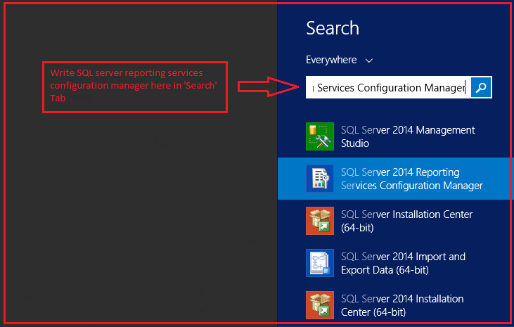

1. You will be able to see below window, once ‘reporting services manager’ will get open. Mention Server and instance name in the below window and then click on connect.

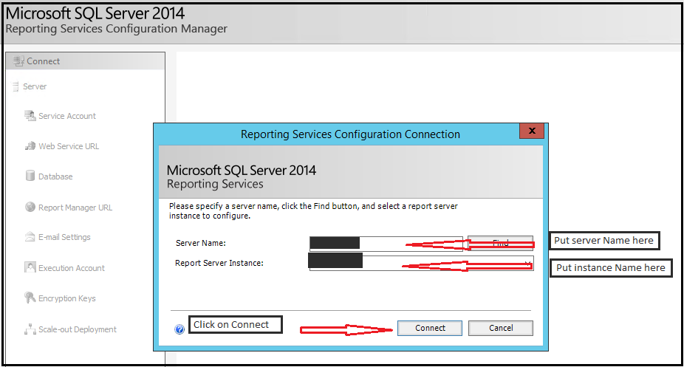

1. After clicking on Connect, you will be able to see below window. Go to Report manager URL and the open the link.

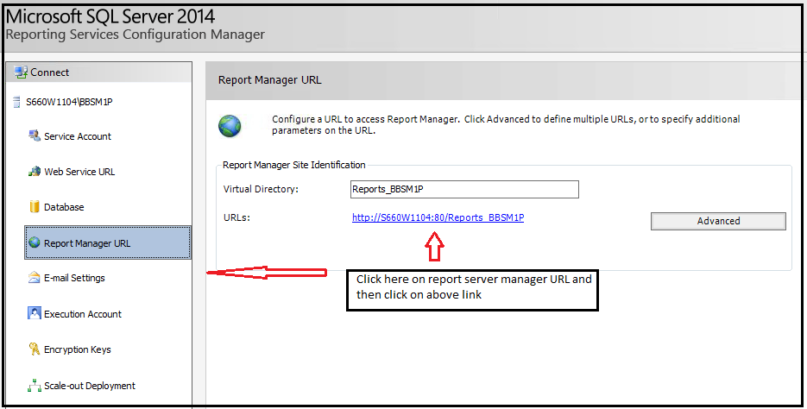

1. After opening the link, you will be able to see below page.

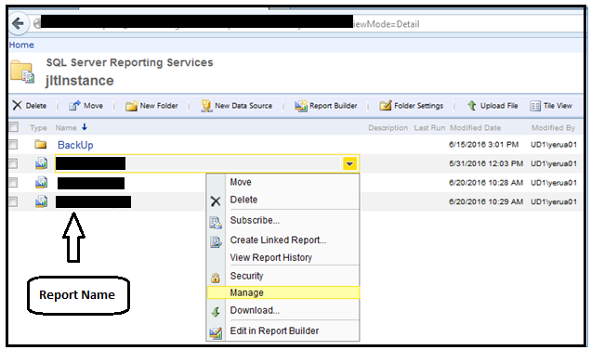

**Step 3:**

Click on Data Source from left hand side menu, provide the connection string to connect to the sql server database.

Provide the credentials to connect to report server during offline. Please check below image for more information.

**NOTE:** Sql Server Login details are mandatory to run/execute report during offline.

Click on Test Connection button, then it will be displayed as “**successfully connected”.**

Click on Apply button.

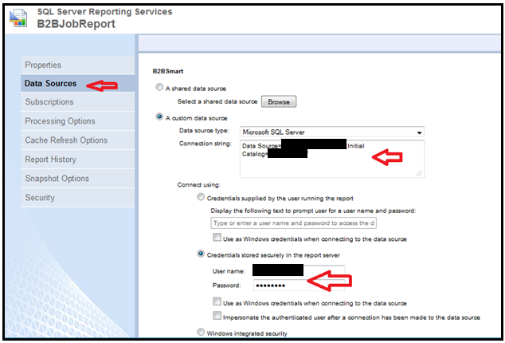

**Step 4:**

Go to Subscriptions option, click on New Subscription button as shown in below image.

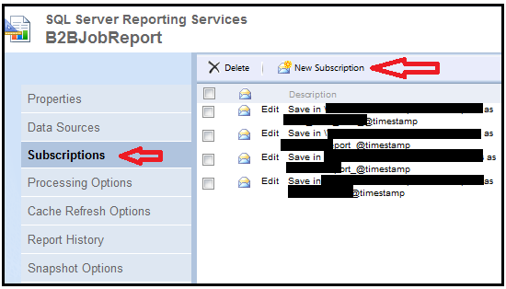

**Step 5:**

Please fallow below steps to implement report subscription.

1. Delivered by: - it should be Windows File Share to place the report file in shared path.
2. File Name: - Give file name
3. Path: - This is the shared path for placing the output of report. At present the files are saving in below path.

\\********\subscriptions\dotReports

1. Render Format: - This is format of file should be generated and place in shared path. As per our requirement we have selected the CSV format.
2. Credentials used to access the file share: - The credentials which we are using should have permissions to place the file in shared path, otherwise it will throw an error.

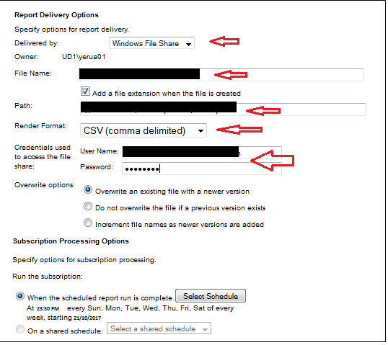

**Step 6:**

Please click on Select Schedule button as show in below image.

**NOTE:** The report will execute automatically based on schedule time.

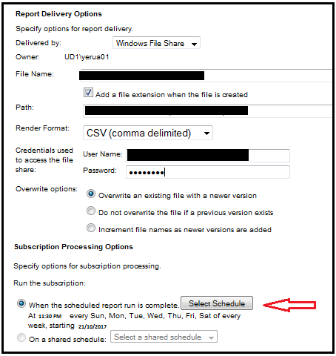

**Step 7:**

Please fill in the schedule details as below:

1. Select Day radio button.
2. Select all day’s check boxes i.e. Sun, Mon, Tue, Wed, Thu, Fri, Sat.
3. Provide **Start time**
4. Begin running this schedule on: Today date, this will tell the subscriptions to run the report from today onwards.
5. Click OK button.

Please check the below image for more information/clarification (Timelines in image are for reference only).

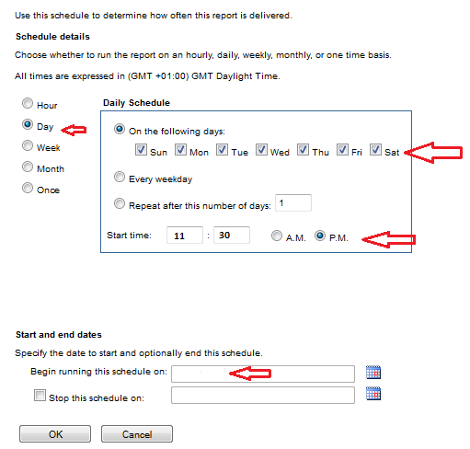

**Step 8:**

We can see the below message, which describes time, day and start date. Click OK button.

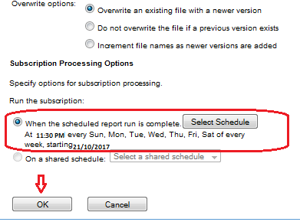

Your report has been scheduled at the scheduled time after clicking ‘OK’